Contents

Section A – Management Summary 3

What is Scrum 3

Pros of Scrum 4

Disadvantages of Scrum 5

Why we chose SCRUM for TOG Order Handling System 5

Section B – High level requirements analysis and MoSCoW prioritisation 7

B1. High level requirement analysis 7

B1.1 Not appropriate high level requirements 7

B1.2 Appropriate high level requirements 8

B2. MoSCoW Prioritisation 10

B2.1. Time Boxing for Project 10

B2.2 Explain how you set about prioritising the requirements and justify your reasons for the decisions that you made. 11

Section C – Legal, Social, Ethical and Professional issues 15

C1. TOG personnel need to start considering Legal, Social, Ethical and Professional Issues (LSEPI) in relation to its day-to-day operations. 15

C2. BCS Code of Conduct 18

REFERENCE 22

# Section A – Management Summary

On this project we decided to make sales through popular peer-to-peer eCommerce websites that allow users to market and sell their products. The company now sells decorations and sculptures, including custom-made pieces, as well as functional items such as cups and vases. The existing platform allows customers to search and browse for items, add them to their shopping cart and make payments using systems enabled by the peer-to-peer eCommerce website, such as PayPal. So the team at TOG decided to develop the system using the SCRUM method using DSDM. However, to make sure this approach is right for their project or not. And to help them believe in the solutions the team at TOG proposed, we will first explain to them how the benefits of SCRUM and why the system of choosing methods developed TOG order processing system.

## What is Scrum

Scrum is a framework utilizing an agile mindset for developing, delivering, and sustaining complex products, with an initial emphasis on software development, although it has been used in other fields including research, sales, marketing and advanced technologies. It is designed for teams of ten or fewer members, who break their work into goals that can be completed within time-boxed iterations, called sprints, no longer than one month and most commonly two weeks. The Scrum Team assess progress in time-boxed daily meetings of 15 minutes or less, called daily scrums. At the end of the sprint, the team holds two further meetings: the sprint review which demonstrates the work done to stakeholders to elicit feedback, and sprint retrospective which enables the team to reflect and improve. In scrum project move forward with series of iteration called Sprints. Each sprint size is typically two to four weeks long. It is based on inspect and adaptive cycle. Producing product incrementally and iteratively reduces the risk and enhance visibility. **Scrum has simple roles, activities and artifacts**

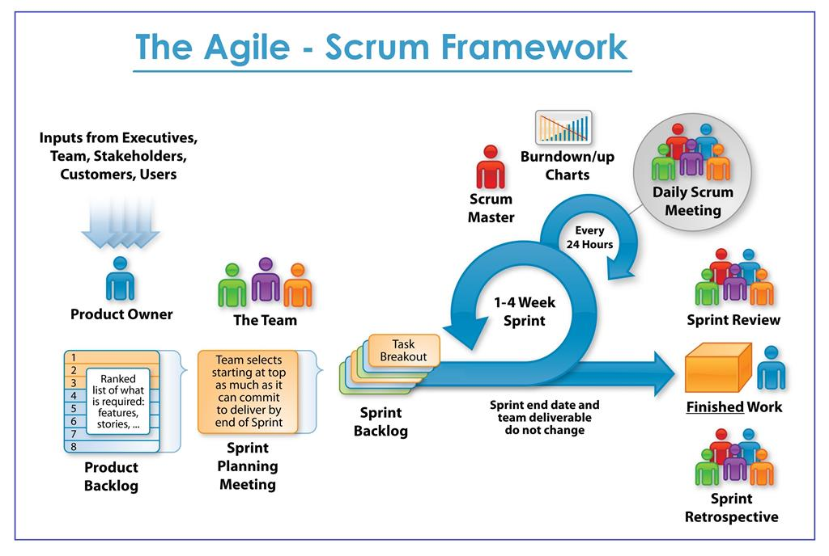

## Pros of Scrum

Customer Satisfaction: The first and most important is getting delighted customers. In Scrum, sprints are really short so results are delivered and are ready for testing within 1-3 weeks. Scrum's main focus is to provide new features or corrections frequently, and collect feedback from clients as quick as possible. Therefore, Scrum speeds up bug fixing processes and the development of new features, making customers happy.

Applying Scrum in development can lead to reducing the cost of production. Product costs are primarily determined by the time and effort spent on new releases. But companies are rarely able to estimate the real, total costs of production.

In Scrum, story pointing can be applied to estimate the complexity of any task. Complexity strongly correlates with the costs of production. Story pointing on each tasks gives you a chance to better estimate the cost of developing new features, and also allows project managers to prioritize tasks based on their complexity.

Enhanced collaboration & communication: The third big area of Scrum’s benefits is the strong focus on collaboration and daily communication. Scrum provides visibility on tasks for each team member to track progress and to allow the better allocation of resources. The strong focus on collaboration leads to a happier, and more productive team.

Two of the key Agile Scrum benefits are quicker response to market demands, and cost savings due to increased performance. According to my experience, Scrum can be used not only in software development but in Agile sales and marketing as well, yielding similar benefits.

## Disadvantages of Scrum

But like every other framework, scrum has a few drawbacks. Nothing is perfect and the Scrum methodology is no exception. In some cases, Scrum combined with other project management techniques can help address some of the following drawbacks:

Scrum often leads to a scope change, due to a lack of a defined end date. Therefore, if the project has a change in scope, it will be difficult to determine the end date and the project will last long affecting the time and cost of the project. The likelihood of project failure is high if individuals do not commit or cooperate. Therefore, personnel in the project must agree on ideas and must resolve personal conflicts in the most reasonable way so as not to affect the project.

Adopting the Scrum framework in large teams is a challenge. The framework can only succeed with experienced team members. Daily meetings are sometimes frustrating for team members. If any of the team members leave in the middle, it could have a major negative impact on the project. Quality is unlikely to work until the team goes through a positive testing process.

## Why we chose SCRUM for TOG Order Handling System

The sprint is shorter and the user stories have priority included in each sprint planning. It ensures that at each sprint delivery, the features requested by the customer are immediately included. The organization can focus on the effort required to develop priority user stories and thus reduce costs and re-work. Due to the specific benefits of scrum on the client, the development team increases efficiency. Because Scrum facilitates quick response, prioritization of work, and adoption of change, a product manager can easily ensure that work is in line with the needs of the customer.

Due to the time-boxed nature of the sprint and the incremental delivery of the product at the end of each sprint, the development team became enthusiastic about seeing that their work was used immediately. Team collaboration is built to delight the team with the work they do. There are several members in the development team who are very knowledgeable about SCRUM, so they have a lot of experience to use SCRUM quickly and effectively. One of the problems with prototyping is that it can get out of hand. Good project control must be performed. So, if an accident does occur, he will easily siege successfully. The SCRUM team must be empowered to make day-to-day design decisions without consulting superiors.

# Section B – High level requirements analysis and MoSCoW prioritisation

## B1. High level requirement analysis

Project management requires a lot of planning and documentation in advance. Often found in the project charter, senior project management requirements reflect the need for an overarching view of work and features that must be completed throughout the project's life cycle judgment.

### B1.1 Not appropriate high level requirements

This project has a number of requirements and those requirements are not necessary for this moment. This type of feature can increase development time and costs. Here are some of the requirements that are not that high for this project at the moment:

* People should be able to sign up for glassblowing classes-This function is not suitable for the project because this project was developed for marketing and selling products, not to teach people how to blow glass.
* As a Customer I want a choice of delivery slots so that I can arrange my diary appropriately-This is not necessary for the project yet and it may be needed in the future.
* As the Operations Manager there needs to an ability to track an item’s lifecycle, from where the order is placed, up to the point where customers sign for the item they receive. Alerts should be sent to people in different phases of the lifecycle, like notifications for a job - With a project in progress this is not necessary as it can delay development of other essential features and this can be done in the future.
* As a Customer I want to choose whether or not I am sent marketing information so that I do not get loads of junk mail-This is not strictly necessary and should not be done because it will increase costs and time.
* As a Warehouse Operative I want to check delivery addresses so that I can place orders with similar postcodes in the same delivery batch-This is not necessary at present as it can be costly and time consuming.
* As the Glassblower Artist I like the idea of having an e-commerce website, but I don’t want tours of the facility and I don’t want to teach people how to do it. Do not put that part in the system – tell them it cannot be done in time-This is unreasonable for development in the project as it is not necessary for implementation as it will be time consuming and costly.
* As a Customer I want to have product wrapped and sent to an address other that than my own so that I don’t have to bother wrapping and delivering presents-This is not required at this time and this can be solved decided by adding a shipping address and will be developed in the future.
* As a Customer I would like to personalise and create my own designs-This is not an essential function in the project because customers can order their own opinion by communicating via text message or phone with the glassblower, rather than through a function feature of the site.
* As a Customer I want daily emails to let me know the status of my order because I get nervous when I don’t know what is going on-This is not necessary at present as it can develop in the future.
* As a customer I want to be able to process returns via the Web site so that I do not have to phone up and answer all of those stupid questions before being put through to a human being-This is not necessary because the return of the goods should go through the person in charge of this matter so that it can be resolved quickly and reasonably.

### B1.2 Appropriate high level requirements

Here are some high level requirements with some briefly and justification of new project:

* Customers must be able to register and log in. However, it would be great if we could already create accounts for customers we know about and e-mail them their usernames and passwords-This functionality is essential because with it, your website can work.
* Customers must be able to search and browse different products, whether they are logged in or not-This functionality is essential because with it, your website can work.
* The look and feel of the website should be well designed and showcase the products well. I also want there to be rotating 3D views of the products-This function is essential because it helps customers to enjoy and easily attract attention for products and websites.
* People should be able to contact us for bespoke items and the system should facilitate communication with them, including messages and sending pictures-This function is essential because people can contact to buy products as well as order their own products in the best way.
* The site must load quickly – This non-function is very necessary because if the website performs poorly then the customer will feel annoyed and may not visit the website again.
* As the Operations Director I want to gather statistics on item popularity-This function is necessary because it helps the statistics necessary to give the right direction for the website to increase sales.
* As a Customer I want to be able to change my account details so that my most up to date details are recorded-This functionality is essential because with it, your website can work.
* The site must be safe and secure-This non-function is essential because it helps to protect customer information as well as to protect the website from illegal access for the purpose of information theft and vandalism.
* As the Marketing Director I would like promotions page so that we can inform our customers of current discounts on offer-This function is necessary because it helps the statistics necessary to give the right direction for the website to increase sales.
* As the Managing Director I want to be ensured that the site is Data Protection Act safe so that we do not get fined hundreds of thousands of pounds-This is essential because it helps the website to function without having to encounter anything legal.

## B2. MoSCoW Prioritisation

When managing a project, it is important to develop a clear understanding of the customers' requirements and their priority. Many projects start with the barest headline list of requirements, only to find later the customers' needs have not been fully understood.

### B2.1. Time Boxing for Project

**Time Boxing for the Project**

We will plan time boxing for the project. Time boxing is required so that the project can give feedback on each time box for iterative development and the end product will fit the business needs. Since the time box is an increment, we will ship the product after each time box has been completed. Since the project management has set a goal that the prototype system will be up and running within 36 days, we set a deadline for the project to be completed within 36 days.

|  |  |  |  |
| --- | --- | --- | --- |
| **ID** | **Requirements** | **Priority** | **Days** |
| **1** | Customers must be able to register and log in. However, it would be great if we could already create accounts for customers we know about and e-mail them their usernames and passwords. | **Must have** | **3** |
| **2** | Customers must be able to search and browse different products, whether they are logged in or not | **Must have** | **5** |
| **3** | The look and feel of the website should be well designed and showcase the products well. I also want there to be rotating 3D views of the products. | **Should** | **3** |
| **4** | People should be able to contact us for bespoke items and the system should facilitate communication with them, including messages and sending pictures. | **Should** | **6** |
| **5** | The site must load quickly. | **Could** | **3** |
| **6** | As the Operations Director I want to gather statistics on item popularity | **Must have** | **5** |
| **7** | As a Customer I want to be able to change my account details so that my most up to date details are recorded. | **Must have** | **3** |
| **8** | The site must be safe and secure | **Could** | **3** |
| **9** | As the Marketing Director I would like promotions page so that we can inform our customers of current discounts on offer. | **Must have** | **3** |
| **10** | As the Managing Director I want to be ensured that the site is Data Protection Act safe so that we do not get fined hundreds of thousands of pounds. | **Must have** | **2** |

**Total days –** 36 days

**Must have –** 21 days (58% of total effort)

**Should have –** 9 days (25% of total effort)

**Could have –** 6 days (17% of total effort)

Correct application and compliance with the MoSCoW Methodology will help you to manage your projects more clearly. Everyone involved in the project will know what needs to be done first, when it has to be done, and why it matters. By prioritizing requirements, a project becomes easier to manage and keep pace with.

Project development or support will also be easier to do by ignoring less important requirements. By focusing on the key requirements, you will complete the project with a salable product that meets the minimum requirements. Therefore, the "Must have" point must be a unique selling point and bring benefits to the buyer.

### B2.2 Explain how you set about prioritising the requirements and justify your reasons for the decisions that you made.

MoSCoW is usually used with timeboxing. Timeboxing is a project planning technique where a time limit is fixed for the focus to be on the most important requirements. MoSCoW is an acronym derived from the first letter of each of four prioritization categories, MUST have, SHOULD have, COULD have, and WON’T have, with the interstitial Os, which apparently means nothing, added to make the word pronounceable. While all the requirements are equally important, they are prioritized in a special way to convey the best and most sudden business benefits early. The developers, in the beginning, will try to deliver all the Must have, Should have and Could have, but the Should and Could requirements are the first to be removed if the delivery timescale is intimidated.

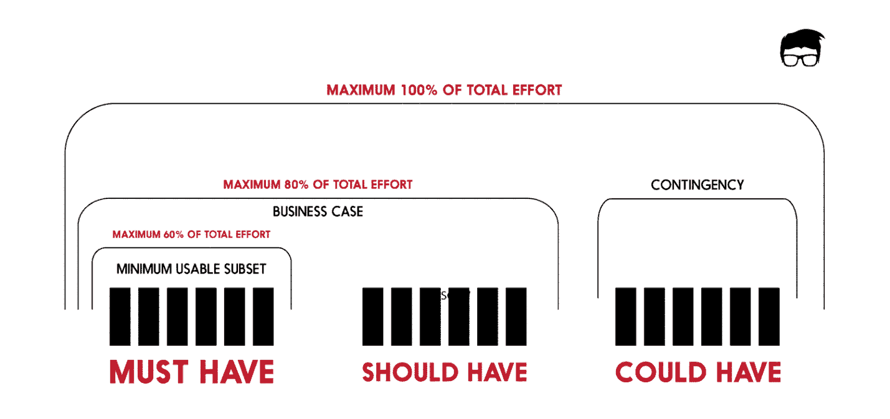

**Reasons is Setting Priorities**

**Requirement 1:** Customers must be able to register and log in. However, it would be great if we could already create accounts for customers we know about and e-mail them their usernames and passwords.

**Priority:** Must have

**Reason:** This functionality is required for the website to work. This is web marketing and sales so this function is required in order to make a purchase.

**Requirement 2:** Customers must be able to search and browse different products, whether they are logged in or not.

**Priority:** Must have

**Reason:** This is necessary for the website to function because it allows users to view the product before making a purchase or placing an order.

**Requirement 3:** The look and feel of the website should be well designed and showcase the products well. I also want there to be rotating 3D views of the products.

**Priority:** Should have

**Reason:** This is a rather necessary function because it helps people have a better view of the product as well as better understand the product.

**Requirement 4:** People should be able to contact us for bespoke items and the system should facilitate communication with them, including messages and sending pictures.

**Priority:** Should have

**Reason:** This is a pretty essential function because people can either order their own product or want more information about the product.

**Requirement 5:** The site must load quickly.

**Priority:** Could have

**Reason:** This is quite necessary because if the website loads slowly, it can be annoying as well as reduce the website's revenue.

**Requirement 6:** As the Operations Director I want to gather statistics on item popularity.

**Priority:** Must have

**Reason:** This is essential because in order to help the operations manager clearly analyze the popularity of products and come up with appropriate measures in the future to increase sales.

**Requirement 7:** As a Customer I want to be able to change my account details so that my most up to date details are recorded.

**Priority:** Must have

**Reason:**  To be able to function this function must be available for the user to be able to change their account information.

**Requirement 8:** The site must be safe and secure.

**Priority:** Could have

**Reason:**  This is essential because it keeps the website running securely and avoids the risk of losing customer information and their data from unauthorized access.

**Requirement 9:** As the Marketing Director I would like promotions page so that we can inform our customers of current discounts on offer.

**Priority:** Must have

**Reason:**  This is very important as it helps the website increase sales.

**Requirement 10:** As the Managing Director I want to be ensured that the site is Data Protection Act safe so that we do not get fined hundreds of thousands of pounds.

**Priority:** Must have

**Reason:**  This is extremely important as it relates to the law. so the site must have this.

# Section C – Legal, Social, Ethical and Professional issues

## C1. TOG personnel need to start considering Legal, Social, Ethical and Professional Issues (LSEPI) in relation to its day-to-day operations.

**Ethical and Legal Issues**

Ethical and legal issues are relevant to any project involving systems development.

– privacy

– professionalism

– ownership

– copyright

– data protection

– effect on employment (redundancies/reskilling)

These issues should be an integral part of systems development - not a “bolt-on”.

Emphasis here should be on the fact that it is perilous to ignore ethical issues and that this should be an integral part of the development process not an add on as an afterthought.

Should be part of the organisations standards/policies.

**Professional Codes of Conduct**

BCS (British Computer Society) Code of Practice and Conduct

ACM (Association of Computing Machinery) Code of Ethics and Professional Conduct.

**Ethics**

‘Ethics is the practice of making a principled choice between right and wrong.’ (Kallman and Grillo)

‘Ethics does not define and then impose a defined set of values.’ (Langford)

‘Ethical issues surrounding computers are new species of old and recurrent moral issues.’ (Johnson)

**Computer Ethics**

Computer crime and the problem of computer security e.g. ATM fraud - 1992 British banks & building societies sued by their customers who claimed unauthorised withdrawals had been made.

Software theft & the problem of intellectual property rights e.g. software piracy.

**Computer Ethics**

Hacking & the creation of viruses A hacker - someone who accesses a computer system without the express or implied permission of the owner. A virus - self-replicating program that causes damage.

Computer unreliability & the question of software quality e.g. 1992, British hospital, over 10 year period 1000 cancer patients had been given incorrect radiation therapy (dosage too low) - undetected program error.

Data storage and the invasion of privacy e.g. DPA (1984,1998)

**The Ten Commandments of Computer Ethics**

* Thou shalt not use a computer to harm other people.
* Thou shalt not interfere with other people's computer work.
* Thou shalt not snoop around in other people's files.
* Thou shalt not use a computer to steal.
* Thou shalt not use a computer to bear false witness.
* Thou shalt not use or copy software for which you have not paid.
* Thou shalt not use other people's computer resources without authorisation.
* Thou shalt not appropriate other people's intellectual output.
* Thou shalt think about the social consequences of the program you write.
* Thou shalt use a computer in ways that show consideration and respect.

From the Computer Ethics InstituteComputer Ethics Institute.

**Legislation**

Data Protection Act (1984,1998)

–Personal data (held on computer) is protected by the Act from 3 potential dangers:

* against being incorrect, incomplete or irrelevant
* against being distributed to unauthorised users
* against being used for a purpose other than that for which it is collected

–8 principles

–Right of subjects to view

Computer Misuse Act (1990)

– unauthorised access to computerised material

* …..with intent to commit or facilitate further offences (eg blackmail re email)
* unauthorised modification of computer material

–Also includes conspiracy to commit the above.

**Other Legislation**

Copyright, Designs & Patents Act 1988

Copyright (Computer programs) Regulations 1992

–Attempt to implement the EC directive on the Legal Protection of Computer Programs 1991

–Copyright of programs (not computer generated)

* author, but if program written by employee in course of employment copyright belongs to employer

–If program written in software house by:

* employee, copyright s’ware house
* outside consultant, copyright consultant unless negotiated

For improper electronic claims & transfers’

* Forgery and Counterfeiting Act 1981
* Theft Act 1968.

**Example:** “TOG Order Handling System has personal data of customer data objects. If government agencies or any third-party organizations request data, Youth Action will have to share them ”.

Personal data is shared only for specific legitimate purposes. Data controllers in the TOG Order Handling System need to check why government agencies or third parties are asking for personal data and what they plan to do with it. The data controller is also responsible for informing the data subject about data sharing and why third parties require their personal data.

**Example:** "While collecting customer personal data, TOG Order Handling System may request some unrelated data such as race and religion."

The data controller in the TOG Order Handling System is only keeping relevant data, not too much for a specific purpose. Excess personal data that is not requested for a specific purpose must be deleted. While sharing personal data with third parties, it is important not to go beyond what they really ask for.

## C2. BCS Code of Conduct

**This Code of Conduct:**

• sets out the professional standards required by BCS as a condition of membership.

• applies to all members, irrespective of their membership grade, the role they fulfil, or the

jurisdiction where they are employed or discharge their contractual obligations.

• governs the conduct of the individual, not the nature of the business or ethics of any

Relevant Authority.

**1. Public Interest**

You shall:

* have due regard for public health, privacy, security and wellbeing of others and the environment.
* have due regard for the legitimate rights of Third Parties
* conduct your professional activities without discrimination on the grounds of sex, sexual orientation, marital status, nationality, colour, race, ethnic origin, religion, age or disability, or of any other condition or requirement
* promote equal access to the benefits of IT and seek to promote the inclusion of all sectors in society wherever opportunities arise.

Example:

You are developing software for the TOG order handling system. When you want to collect data right through the customer is what data will be collected. Avoid violating the privacy and security of our customers.

**2. Professional Competence and Integrity**

You shall:

* only undertake to do work or provide a service that is within your professional competence.
* NOT claim any level of competence that you do not possess.
* develop your professional knowledge, skills and competence on a continuing basis, maintaining awareness of technological developments, procedures, and standards that are relevant to your field.
* ensure that you have the knowledge and understanding of Legislation and that you comply with such Legislation, in carrying out your professional responsibilities.
* respect and value alternative viewpoints and, seek, accept and offer honest criticisms of work.
* avoid injuring others, their property, reputation, or employment by false or malicious or negligent action or inaction.
* reject and will not make any offer of bribery or unethical inducement.

Example:

In order for the project to be successful, both you and everyone in the TOG Order handling system project need to improve your technology knowledge as well as expertise and encourage and help each other to get things done.

**3. Duty to Relevant Authority**

You shall:

* carry out your professional responsibilities with due care and diligence in accordance with the Relevant Authority’s requirements whilst exercising your professional judgement at all times.
* seek to avoid any situation that may give rise to a conflict of interest between you and your Relevant Authority.
* accept professional responsibility for your work and for the work of colleagues who are defined in a given context as working under your supervision.
* NOT disclose or authorise to be disclosed, or use for personal gain or to benefit a third party, confidential information except with the permission of your Relevant Authority, or as required by Legislation.
* NOT misrepresent or withhold information on the performance of products, systems or services (unless lawfully bound by a duty of confidentiality not to disclose such information), or take advantage of the lack of relevant knowledge or inexperience of others.

Example:

TOG Order handling system data about customers. Its sensitive information, you must not use them for your own personal gain. When developing a system, if it is error or stolen, it is to be blamed for not hiding or disparaging the organization.

**4. Duty to the Profession**

You shall:

* accept your personal duty to uphold the reputation of the profession and not take any action which could bring the profession into disrepute.
* seek to improve professional standards through participation in their development, use and enforcement.
* uphold the reputation and good standing of BCS, the Chartered Institute for IT.
* act with integrity and respect in your professional relationships with all members of BCS and with members of other professions with whom you work in a professional capacity.
* notify BCS if convicted of a criminal offence or upon becoming bankrupt or disqualified as a Company Director and in each case give details of the relevant jurisdiction.
* encourage and support fellow members in their professional development.

Example:

When the TOG Order handling system is successfully developed, people should exchange experiences with each other to improve their own level.

# REFERENCE

Simplilearn.com. 2021. *Advantages and Disadvantages of Scrum*. [online] Available at: <https://www.simplilearn.com/scrum-project-management-article> [Accessed 6 April 2021].

En.wikipedia.org. 2021. *Scrum (software development) - Wikipedia*. [online] Available at: <https://en.wikipedia.org/wiki/Scrum_(software_development)> [Accessed 6 April 2021].

Moksony, R., 2021. *What Are the Main Benefits of Using Scrum?*. [online] Content.intland.com. Available at: <https://content.intland.com/blog/agile/the-main-benefits-of-using-scrum> [Accessed 6 April 2021].

Tutorialspoint.com. 2021. *Scrum - Benefits - Tutorialspoint*. [online] Available at: <https://www.tutorialspoint.com/scrum/scrum_benefits.htm> [Accessed 6 April 2021].

C-sharpcorner.com. 2021. *The Agile - Scrum Framework*. [online] Available at: <https://www.c-sharpcorner.com/UploadFile/d9c992/the-agile-scrum-framework/> [Accessed 6 April 2021].

Project Smart. 2021. *MoSCoW Method*. [online] Available at: <https://www.projectsmart.co.uk/moscow-method.php> [Accessed 6 April 2021].

Sydeek, R., 2021. *MoSCoW Method Explained | Feedough*. [online] Feedough. Available at: <https://www.feedough.com/moscow-method-explained/> [Accessed 6 April 2021].

Johnson D G, Computer Ethics, 2nd edition, Prentice Hall, 1994

Kallman E A and Grillo J P, Ethical Decision Making and IT, 2nd edition, McGraw-Hill, 1995

Forester T and Morrison P, Computer Ethics, 2nd edition, MIT Press, 1994

Bcs.org. 2021. [online] Available at: <https://www.bcs.org/media/2211/bcs-code-of-conduct.pdf> [Accessed 6 April 2021].